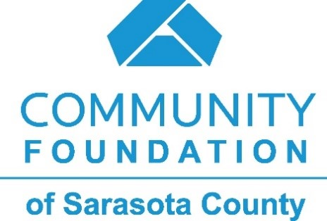

For Immediate Release: CONTACT:
October 21, 2021 Hunter Carpenter
Manager, Communications and Marketing
941.404.9070 (c) | hcarpenter@cfsarasota.org

Community Foundation of Sarasota County Awards 12 Grants Promoting Equity for Healthcare, Education, and Human Services
The more than $320,000 in funding will support nonprofit organizations in equitably expanding access to services and opportunities.
PHOTO I.D. – A student and teacher dive into a spelling lesson at SOAR Learning Center, one of several nonprofit grantees awarded an Equity and Access Grant. Photo by Karen Arango Photography.
SARASOTA, FL – The Community Foundation of Sarasota County has awarded 12 nonprofit organizations with grants totaling more than $320,000 in its third Equity and Access competitive grant cycle. The support will strengthen local, direct service programs focused on serving populations within Sarasota, Manatee, Charlotte, and DeSoto counties that face systemic barriers to healthcare, education, and human services.
While each proposal centered its own unique cause – from mobile health clinics to STEM experiences for young students living with disabilities – all shared a commitment to strengthen their diversity, equity, and inclusion framework and build a region where all who call it home can thrive. Access to healthcare and human services emerged as top priorities as a diverse committee of volunteers, staff, board members, and community leaders reviewed each application and made decisions enriched by their own experiences.
“Together can we create a community where everyone has the ability, support, and opportunity to live a better life,” says Kirsten Russell, Vice President of Community Impact at the Community Foundation. “The promise behind each one of these causes is inspiring and gives hope and voice to so many who have historically been left out of the conversation. These grant awards are one step among several that are positively changing this narrative.”
Organizations Supported: Promoting Equity in Health Care and Human Services
- ALSO Youth
- Boys & Girls Clubs of Sarasota and DeSoto Counties
- CenterPlace Health
- Children First
- Easterseals Southwest Florida
- Just for Girls
- Mote Marine Laboratory
- Mothers Helping Mothers
- Multicultural Health Initiative
- SOAR Learning Center
- The Literacy Council of Sarasota
- We Care Manatee
Since its inception in 2020, the Equity and Access Grant cycles have awarded $775,000 to 33 local nonprofit organizations, each serving one or several populations: geographically underserved neighborhoods, communities of color, immigrants, refugees, and English language learners, persons with disabilities, LGBTQ+ communities, and single mothers, among others.
Looking Ahead
The Equity and Access competitive grant cycle is offered twice a year. Applications for the second cycle will open December 7, 2021. Eligible nonprofit organizations are encouraged to apply at www.cfsarasota.org/nonprofits/grants by the deadline of January 28, 2022.
The Community Foundation of Sarasota County is committed to improving the lives of all people. We believe the strength of our community is in its diversity. Together, we strive to address issues and create opportunities so all people can achieve their full potential. To learn more about our commitment to Diversity, Equity, and Inclusion, visit www.cfsarasota.org/about/diversity-equity-inclusion.

###

About the Community Foundation of Sarasota County: The Community Foundation of Sarasota County is a public charity founded in 1979 by the Southwest Florida Estate Planning Council as a resource for caring individuals and the causes they support, enabling them to make a charitable impact on the community. With assets of $421 million in more than 1,500 charitable funds, the Community Foundation awarded grants and scholarships totaling $48.9 million dollars last year in the areas of education, the arts, health and human services, civic engagement, animal welfare and the environment. Since its founding, the Community Foundation has been able to grant more than $323 million to area nonprofit organizations to our community thanks to the generosity of charitable individuals, families, and businesses. For more information, visit www.CFSarasota.org or call (941) 955-3000.

